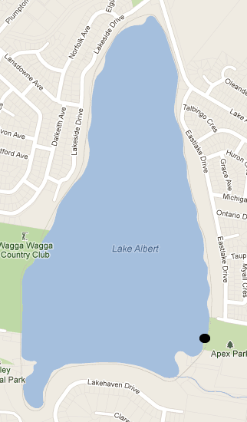2018 KHS Cross Country Course

?

A

B

C

**Finish line for all.**

**4km Start**

14, 15 years Boys and Girls

16/17/18yr Girls

**3km Start**

12/13 yr Boys 12/13 yr Girls

Legend:

Start / finish point

Checkpoint

**6km Start**

16/17/18y Boys