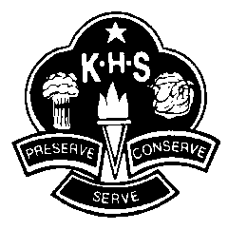

Kooringal High School – Sports Selections Term 2, 2017

Dear Parents/Guardians,
In Term 2, Year 7 & 8 Boys have a choice of two sports:

Football Sports OR Soccer
Place: KHS Top Oval Henwood Park – Bottom Oval
Cost: Free Free

Could you please discuss these options with your child/ward and have them return the note below to the box in the Maths Staffroom by Monday 3rd April.

__________________________________________________________________________________
I hereby give permission for my child ________________________________________________________ of Year_____________ to participate in (please tick one of the boxes below):
□Football Sports (Rugby League/Union, Touch Football and AFL)
□Soccer

Signed: ____________________________ Date: __________________

J. Absolum & L. Davies (Sports Organisers)

